MoviesDen Cinema

**DESIGN Guide**

**GROUP MEMBERS:**

|  |  |
| --- | --- |
| **Students1681274** | **Ubaid ur rehman** |
| **Students1683239** | taha ahmed |
| **Students1681267** | Usman khan |
| **Students1683211** | Mahek fatima |
| **Students1683214** | **Fareed ul hassan** |

**CURRICULUM:** **ACCP AI**

**SEMESTER:** **CPISM**

**FACULTY:** miss maryam masood

**CERTIFICATE OF RECOGNITION:**

**This is to certify that [Ubaid ur rehman, Syeda mahek fatima, usman khan, syed fareed ul hassan, taha ahmed] has successfully completed the project titled “MoviesDen – Online Movie Streaming & Review Website” as part of the academic requirements.**

The project demonstrates exceptional creativity and technical expertise in designing an engaging, dynamic, and user-friendly movie website. It features categorized movie collections, genre-based browsing, trailers, ratings & reviews, smooth navigation, a comparison of trending films, and a visually rich gallery of featured movies.

The overall layout maintains consistency in theme and color schemes, offering an appealing cinematic experience to users.

This certificate is awarded in recognition of the students’ dedication, innovative design approach, and commitment to achieving professional standards in web development.

**Presented On:** dec 10**,2025**

**Authorized Personality: Miss maryam masood**

**ACKNOWLEDGEMENT:**

I would like to express my sincere gratitude to my project guide and all those who supported me throughout the completion of my project titled MoviesDen **– Online Movie & Entertainment Website.”** Their valuable guidance, constant encouragement, and constructive suggestions helped me successfully design and develop this project.

I am also thankful to my teacher **[miss maryam masood]** and my institution for providing me with the resources and environment to enhance my creative and technical skills in web development.

Lastly, I extend my heartfelt thanks to my friends and family for their continuous motivation and support, without which this project would not have been possible.

**SYNOPSIS:**

The project **“MoviesDen – Online Movie & Entertainment Website”** aims to create an engaging, visually appealing, and user-friendly digital platform for showcasing movies, web series, and cinematic content. The website features well-organized categories based on genres, languages, and popularity, ensuring smooth navigation and an immersive viewing experience. It includes sections such as **Home, Trailers, Movie Gallery, Trending & Comparison, About Us, and Contact Us with map integration.**

High-quality optimized images and videos with proper alt attributes enhance accessibility and overall performance. The layout maintains consistent color themes for a modern cinematic feel.

Overall, the project reflects strong creativity and technical expertise in developing a dynamic, interactive, and professional movie-themed website.

**Categories:**

The website **“MoviesDen – Online Movie & Entertainment Website”** features a wide range of categories to help users explore movies and shows easily. The content is organized by **genre**, including popular categories such as **Action, Comedy, Drama, Thriller, Horror, Romance, Sci-Fi, Fantasy, Adventure, Animation,** and **Documentary**.

It also categorizes movies by **language**, such as **English, Hindi, Urdu, Tamil, Telugu, Punjabi, Malayalam, Kannada, Korean, and Japanese.**

Further classification is provided by **movie type**, including **Bollywood, Hollywood, South Indian Cinema, Pakistani Cinema, Animated Films, Web Series, and Short Films.**

Users can also browse movies based on **release year**, such as **Latest Releases, Upcoming Movies, Classics,** and **Top Rated Films.**

Additional categories include **cast-wise browsing**, allowing users to explore films of popular actors and directors. Dedicated sections for **Trailers, Reviews, OTT Trends,** and **Box Office Collections** offer deeper insights into the cinematic world.

The platform also features curated lists like **Top 10 Trending, Most Watched, Critically Acclaimed, Family Movies, Kids’ Collection,** and **Award-Winning Films**, ensuring a rich and engaging entertainment experience for users.

**Distribution:**

You can easily find the location of our cinema or theaters using our website. Additionally, you can explore reviews and experiences shared by other users about movies and screenings. Our website also provides detailed information about the services we offer, helping you make informed decisions and enjoy a seamless movie-watching experience.

**PROBLEM STATEMENT:**

Theatre Show is a website designed to provide information about various theatre shows, including where and when they are taking place. The website offers details about theatre events in different languages. It also includes information about well-known theatre artists. The purpose of the application is to give users easy access to upcoming events, artist profiles, and theatre-related updates in one place.

**Requirement Specification:**

## ****1. Home Page****

The homepage must have a visually appealing and consistent color scheme.

All required navigation links should be clearly defined.

The layout should be fully utilized to avoid unnecessary blank spaces.

## ****2. Content Sections****

The website must include detailed information about:

**Urdu Theatre Shows**

**Hindi Theatre Shows**

**English Theatre Shows**

**Auditoriums**

**Theatre Speak (Reviews & Discussions)**

**Artist Gallery**

**Upcoming Shows**

**Venue details** of current and upcoming shows

## ****3. Awards Section****

The website should include details of awards related to theatre and artists.

## ****4. Navigation****

The navigation throughout the website must be smooth, user-friendly, and consistent on every page.

## ****5. Theatre Speak****

This section should include detailed reviews, comments, and discussions about theatre shows.

## ****6. Auditoriums****

The website must display a list of auditoriums where theatre events are held.

## ****7. Upcoming Events****

A proper list of upcoming theatre events must be included and regularly updated.

## ****8. Magazines****

Theatre-related magazines and publications should be included in this section.

## ****9. Design Uniformity****

A consistent design theme, colors, and styling should be maintained across all pages.

## ****10. Artist Gallery****

The website must contain an artist gallery with images and details of theatre artists.

## ****11. Feedback Section****

A feedback form or section should be available for users to submit their opinions.

## ****12. Queries Section****

A query submission section may be included for users to ask questions or request information.

**Guide:**

**NAVBAR:**

This is our navigation bar. It contains links to all the pages, and when you click on any link, that specific page will open.



**RESPONSIVE NAVBAR:**

This is our navigation bar. It contains links to all the pages, and when you click on any link, that specific page will open. JavaScript is also used in this navbar to make it interactive and functional.

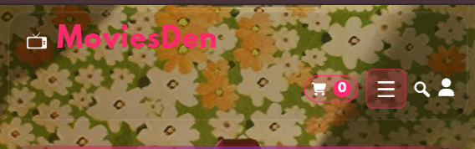

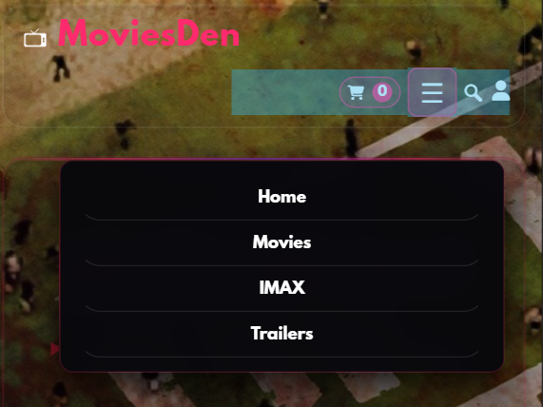

**Hero Section:**

This is our hero section. It shows the main banner of our website with attractive images and text. It gives a beautiful first look to the visitors and tells them about our Cinema.

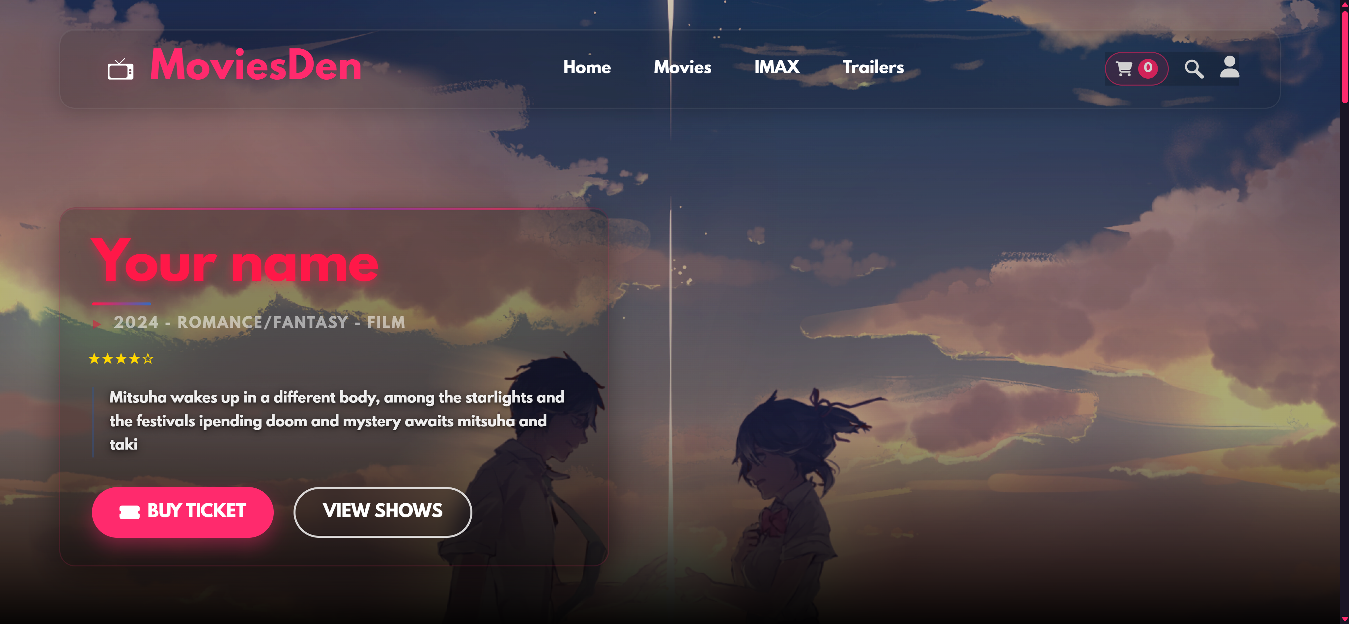

**Collection:**

This is our collection section. It shows different brands and clothing categories. Visitors can see the latest Movies and choose their favorite Movie from here.

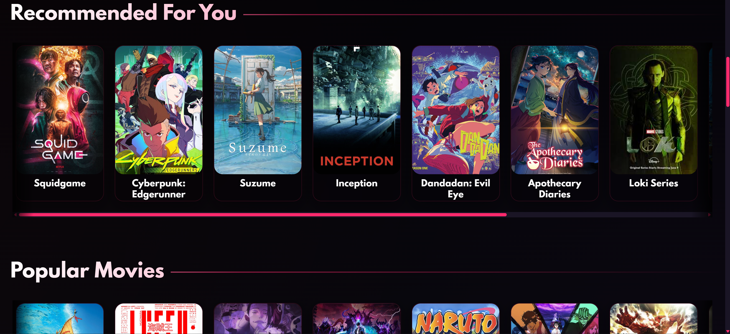

**Genres :**

Packed with high-energy sequences, thrilling stunts, and intense battles.  
Action movies keep you on the edge of your seat from start to finish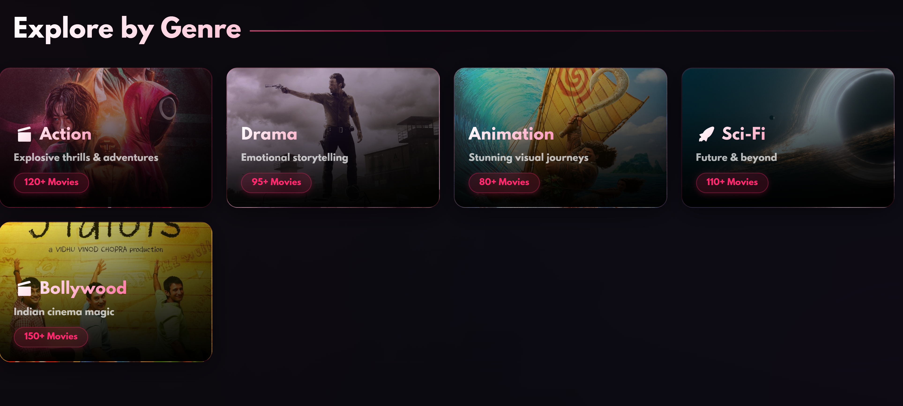

**Trending now:**

INtrending now section people can choose their fav movie and can see what movie is trending rn

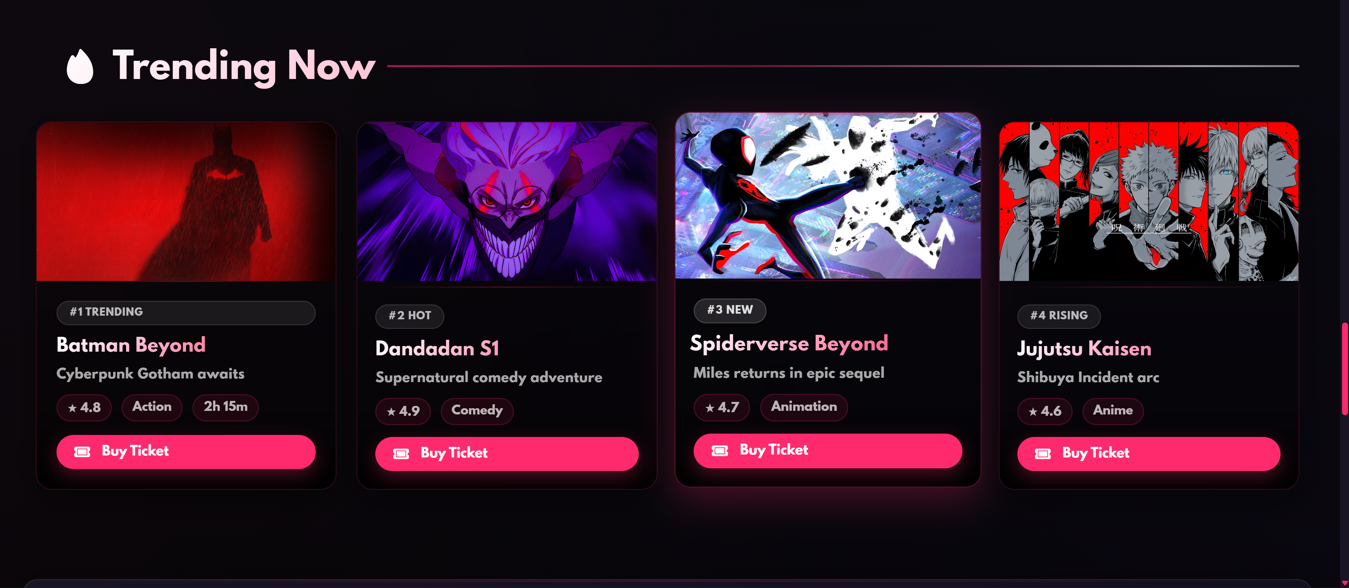

**Movies By days :**

People can choose the day they want to see the movie in 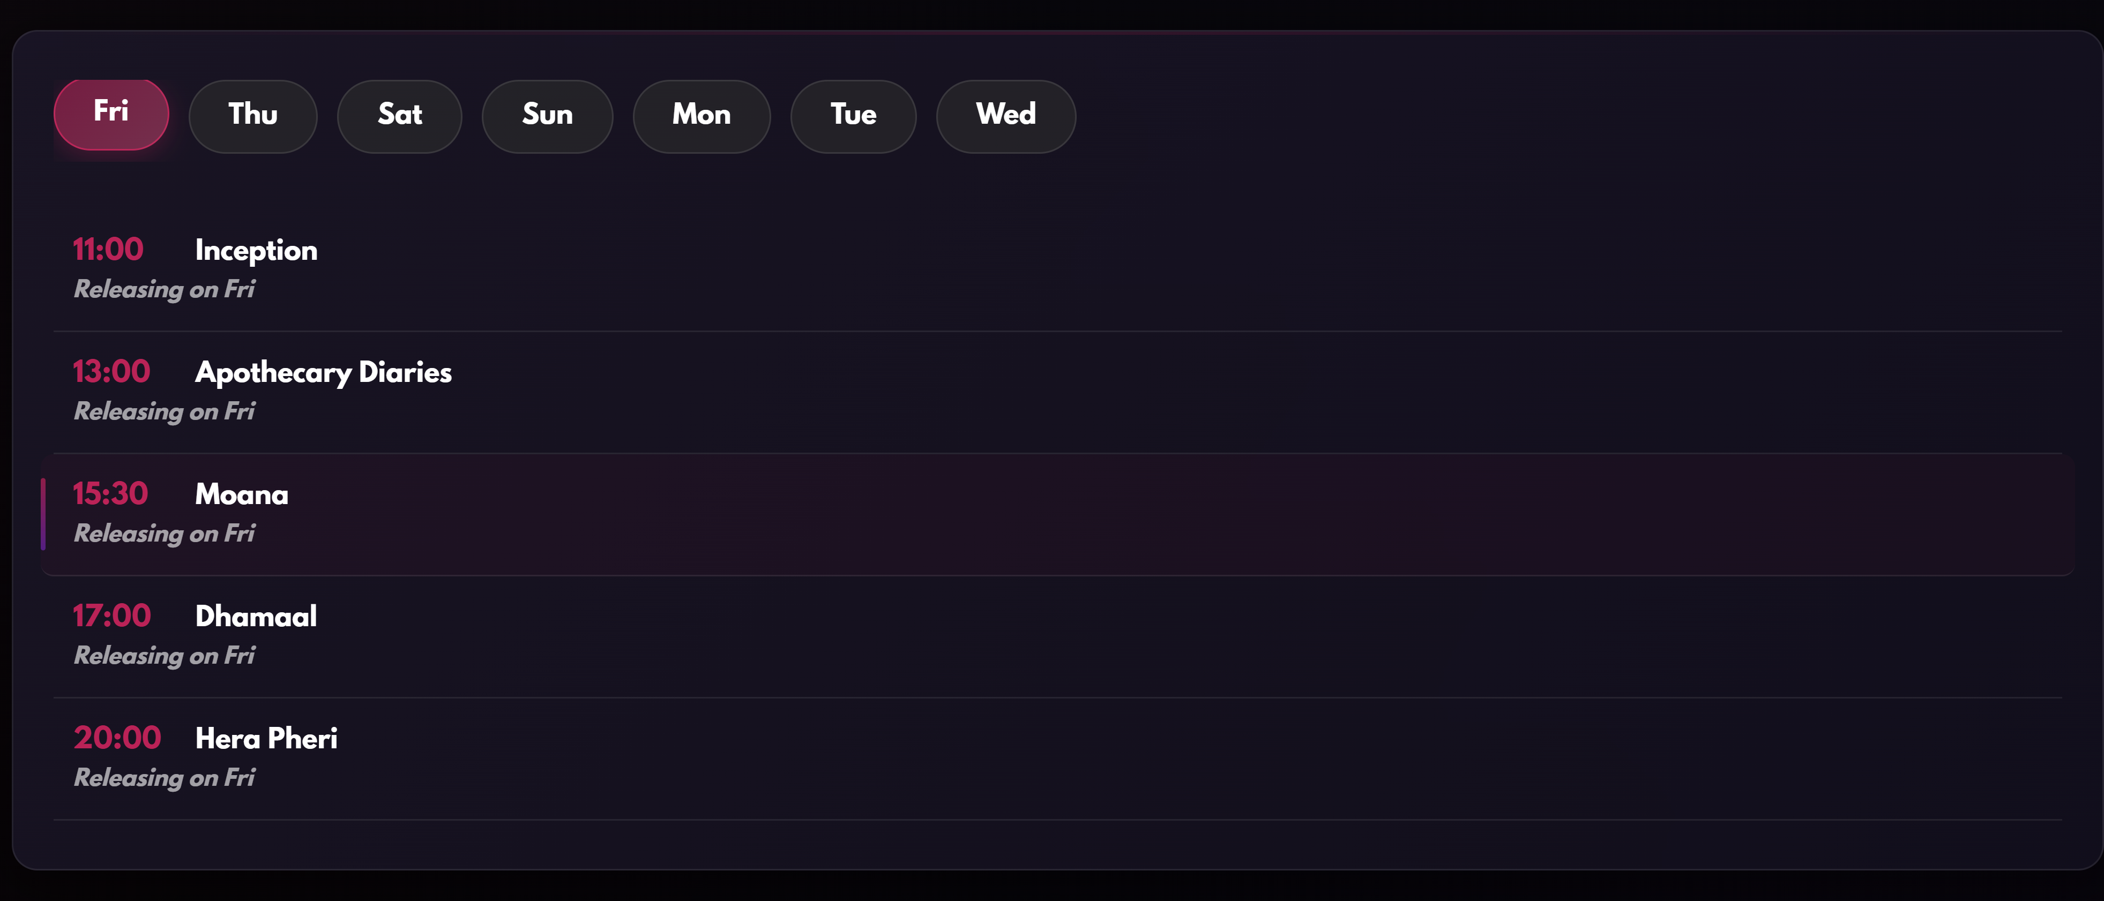

**Movies Page:**

Movies is a page where people can deicide and choose the best movie

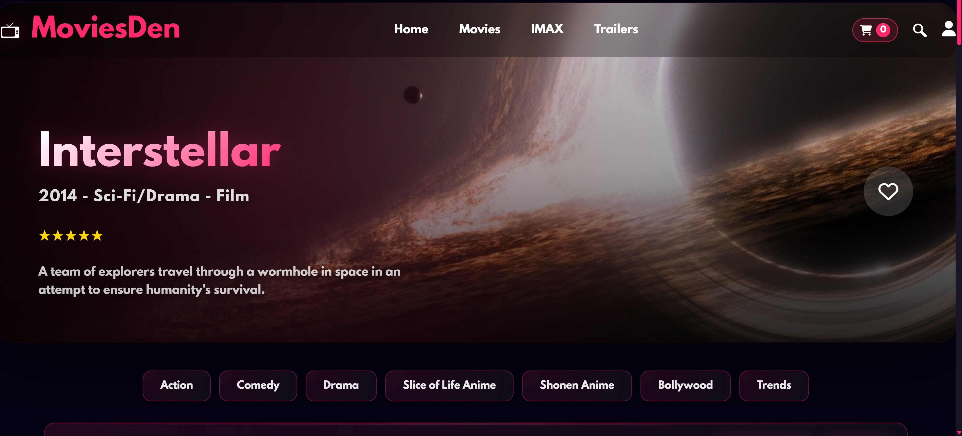

**Movies Hero:**

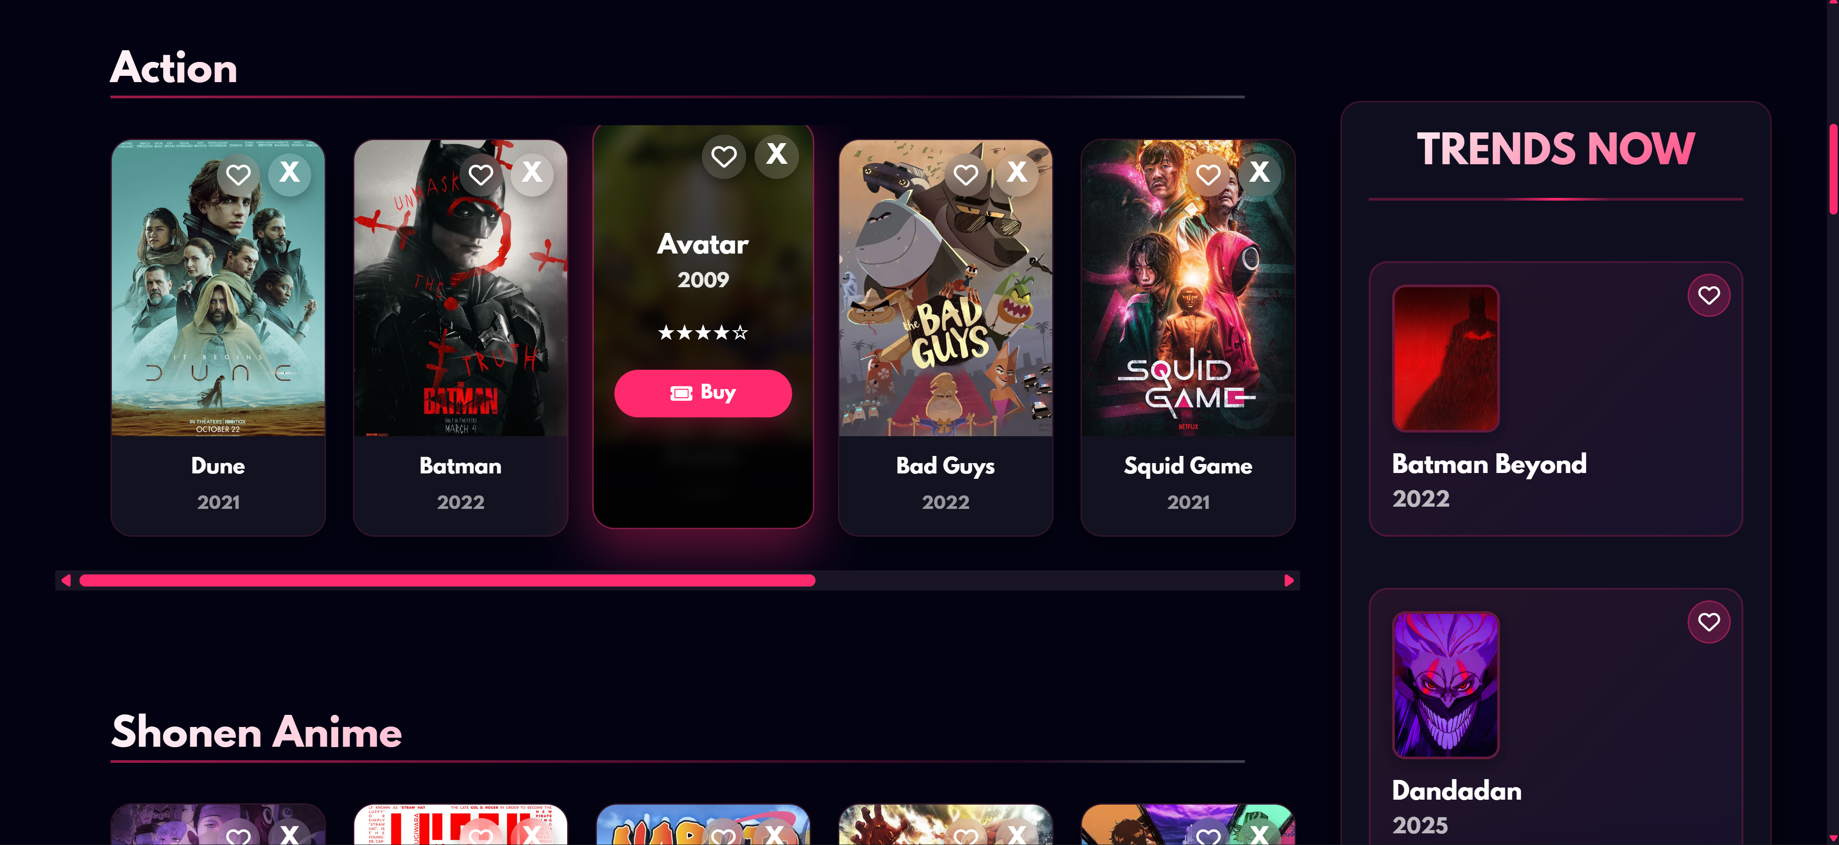**Reviews:**

**People can write their reviews here and show our website and repres3ent it**

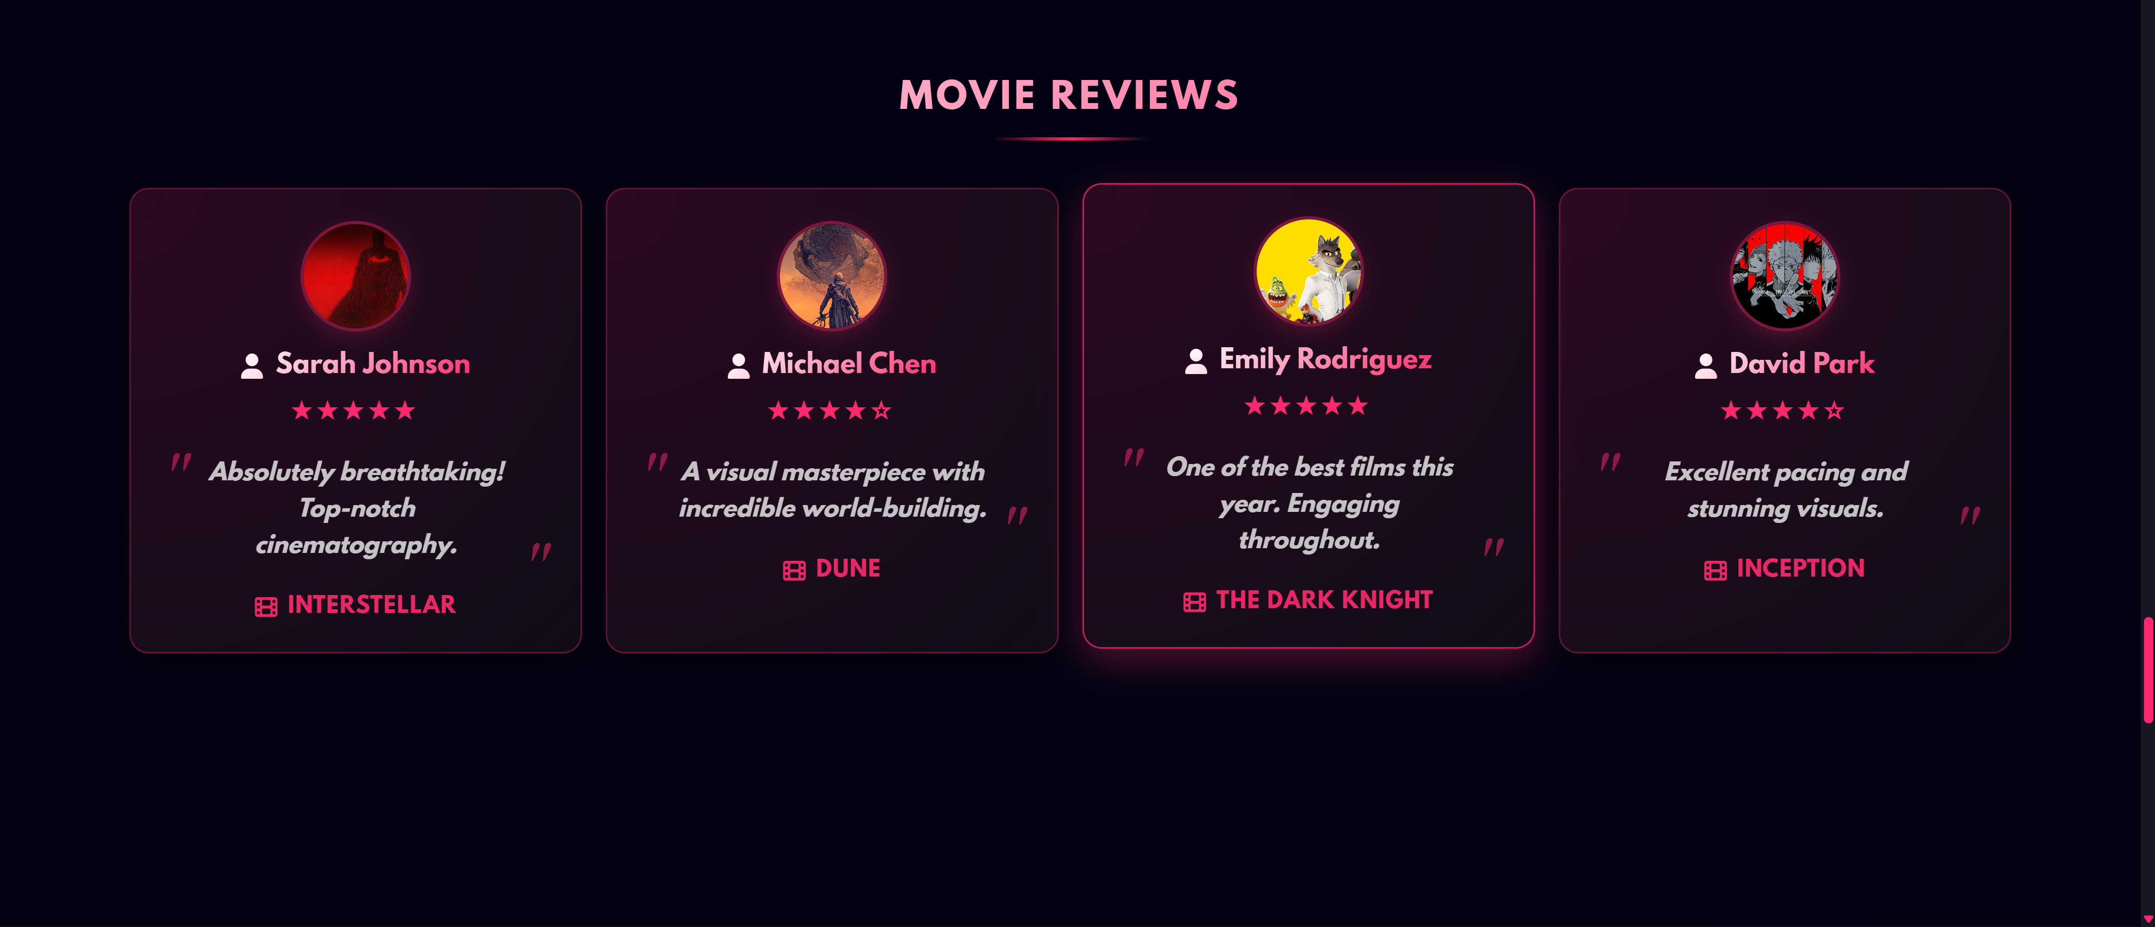

**Their expirence:**

**People can write their expoiernce and share it with everyone**

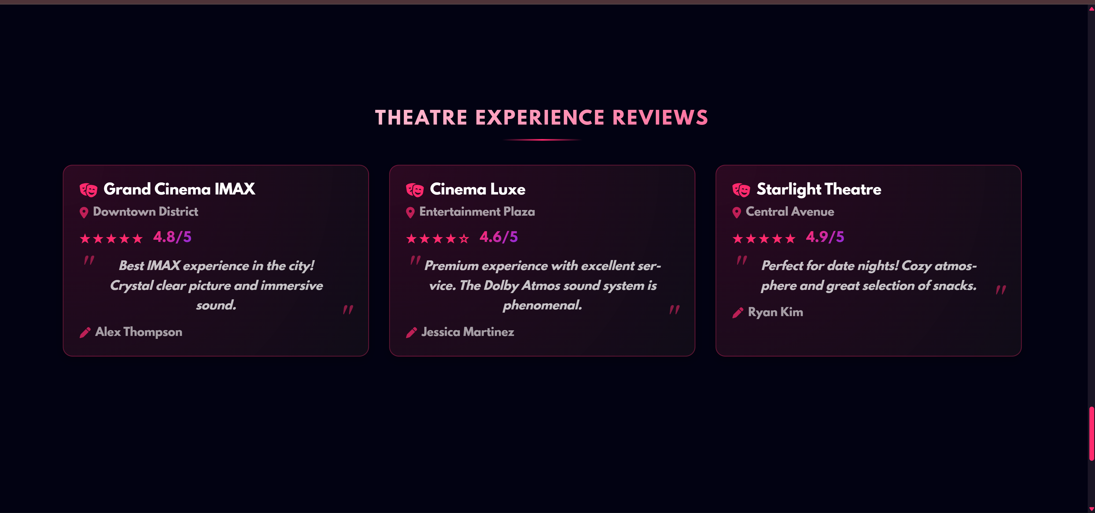

**About:**

about page tells everythiung about us and tells evberyone sbout our team server and eveything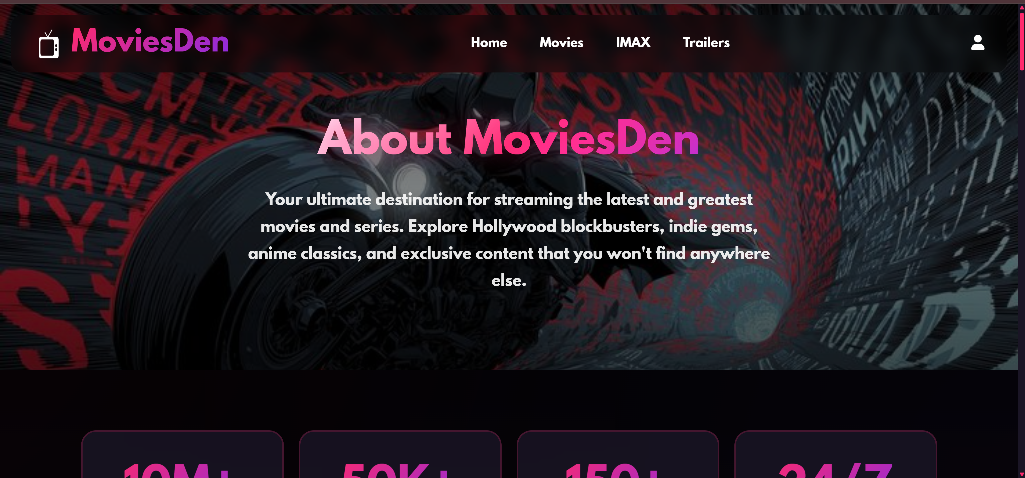

**Login:**

This is our contact us page. Where people can demand a movie or message us about something

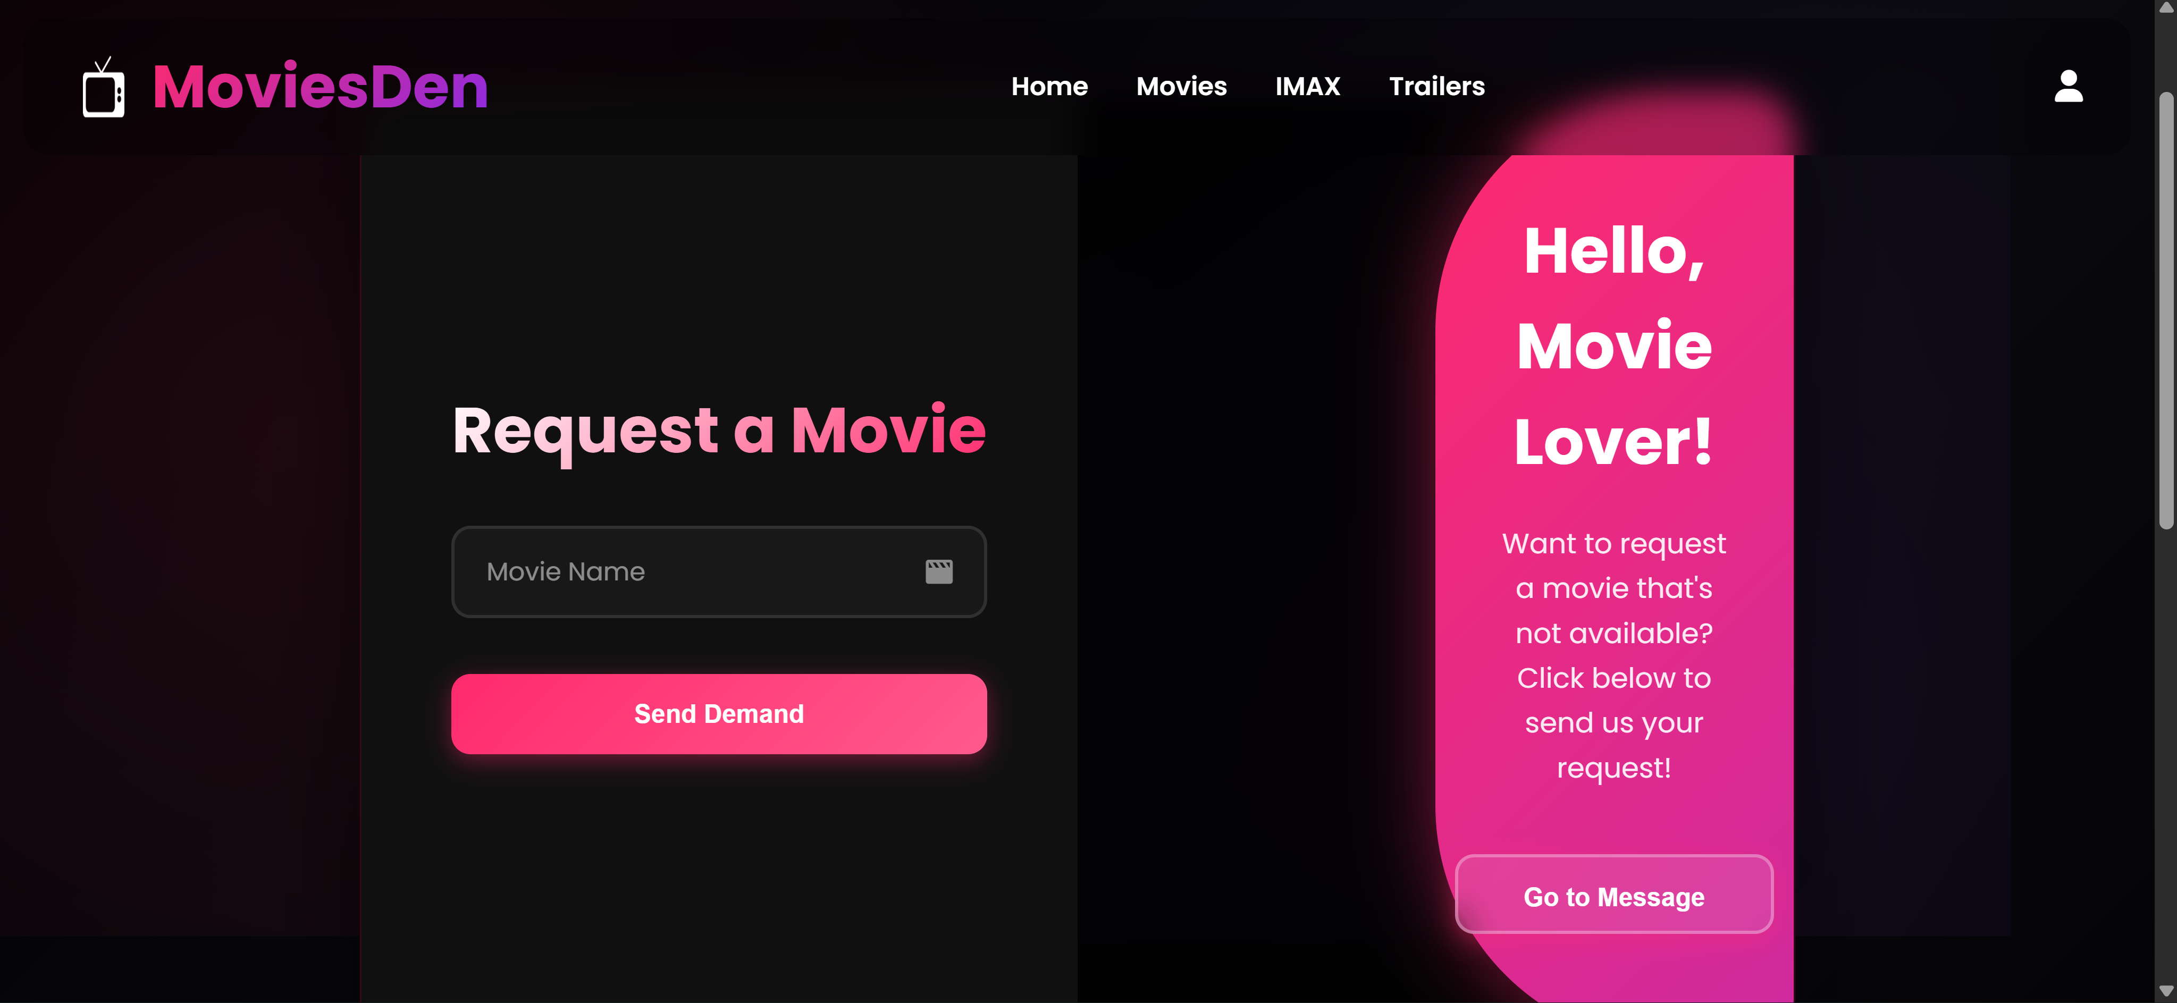

**Signup:**This is the Sign Out page of our website.  
Users can safely log out and end their session here

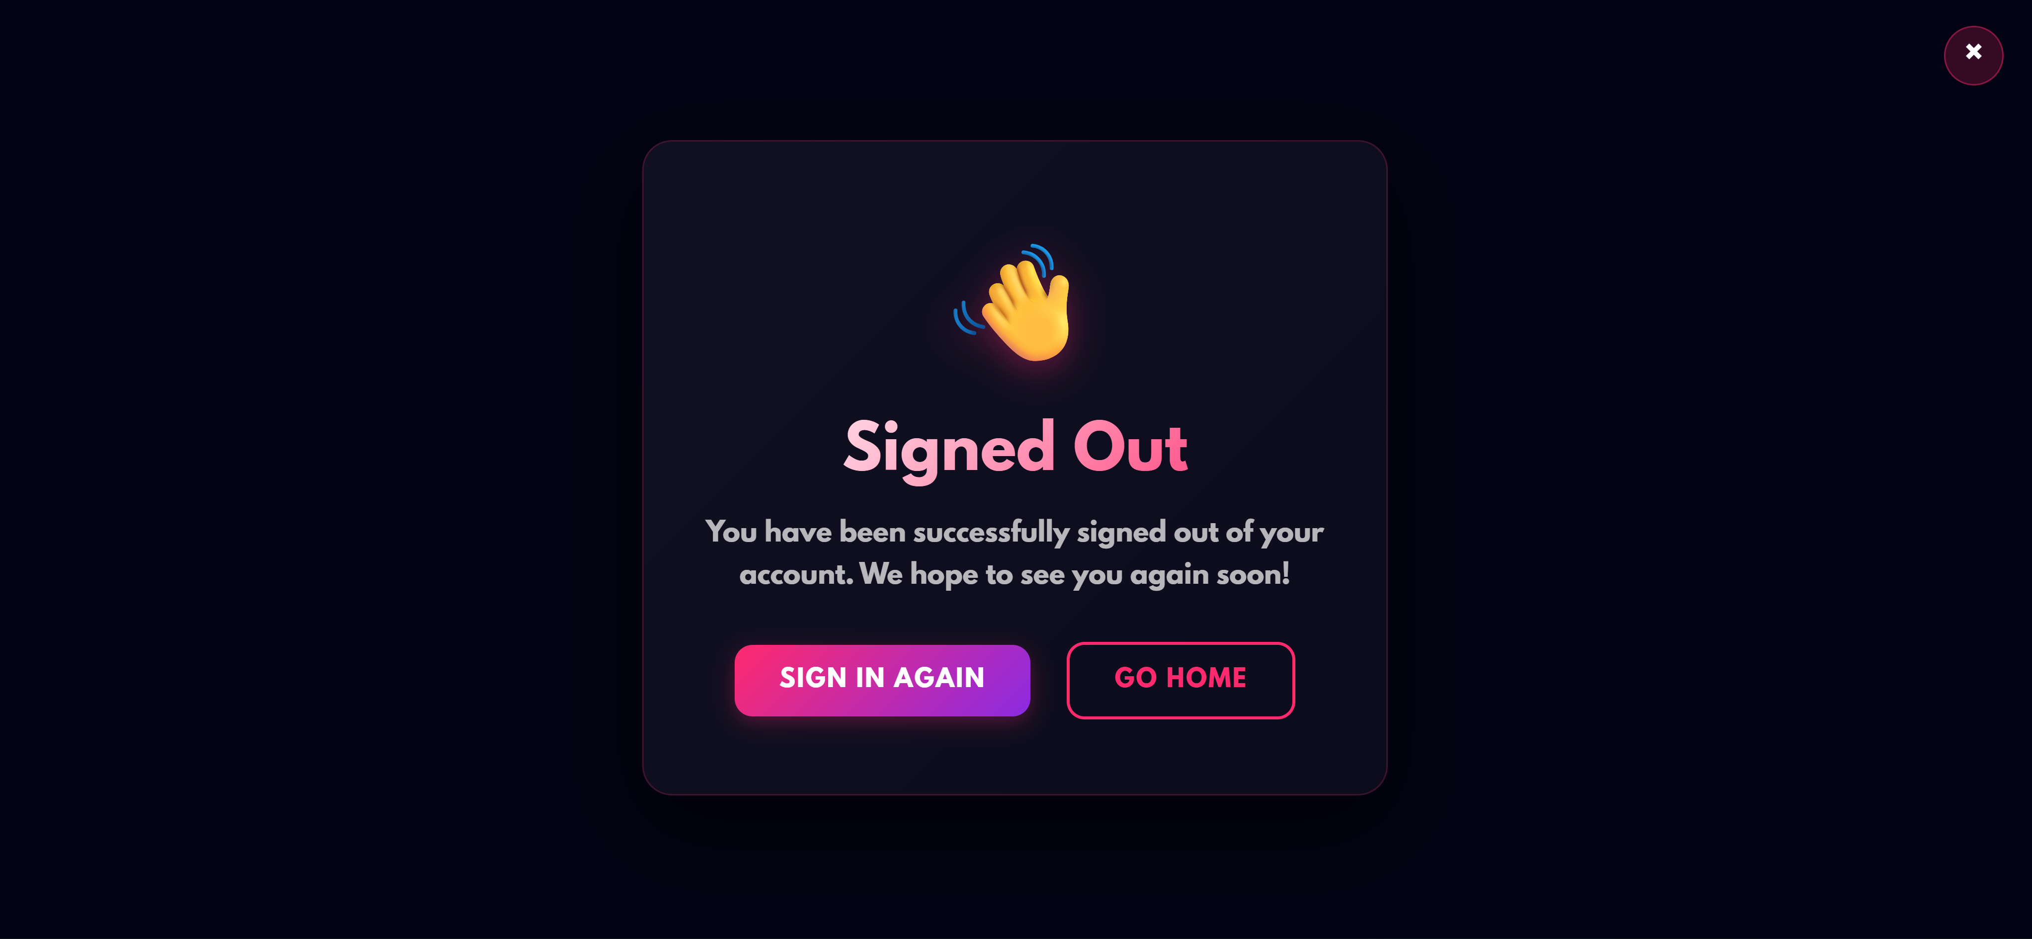

**Movies:**

Movies are a form of visual storytelling that entertain, inspire, and inform.  
They combine acting, direction, music, and visuals to create memorable experiences.  
From action-packed adventures to emotional dramas, there’s something for everyone.  
Movies bring stories to life, allowing audiences to escape into different world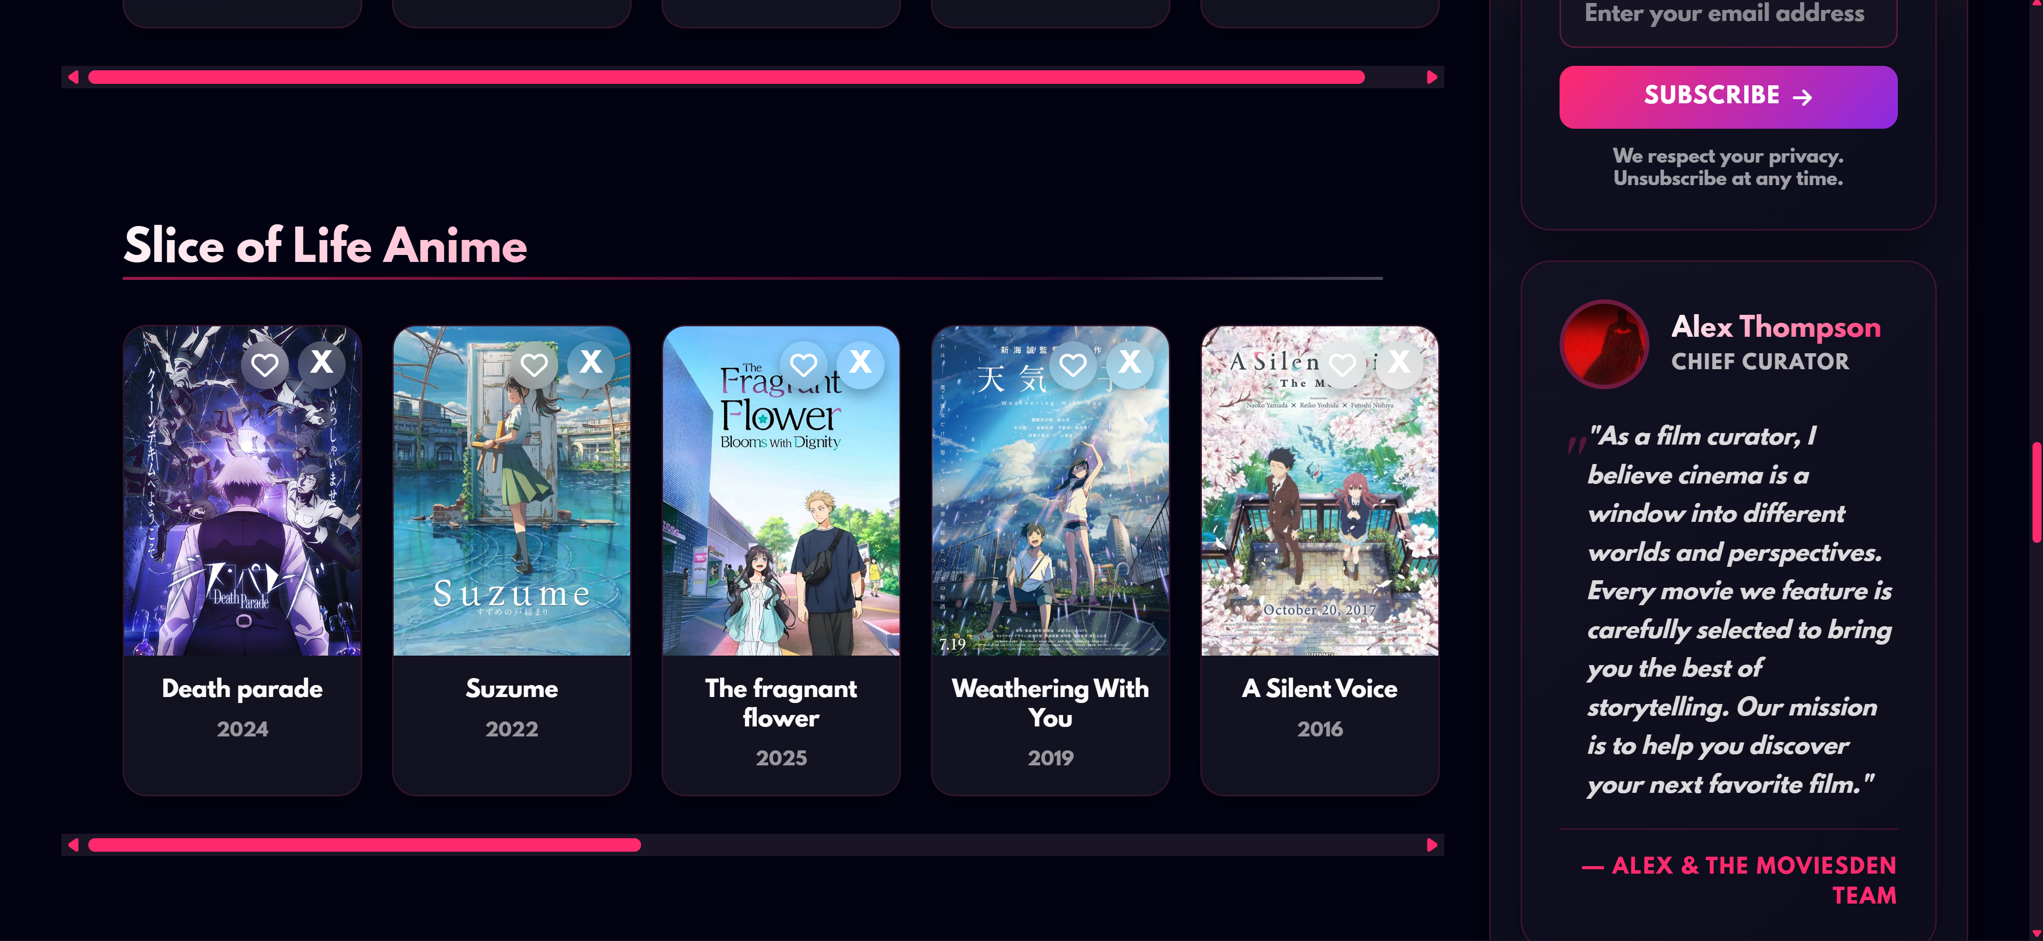

**Privacy Terms and condition:**

These are the Terms and Conditions for using our website and services.  
By accessing our site, users agree to follow all rules and guidelines outlined here.  
We are not responsible for any misuse or unauthorized activities by users.  
Please read carefully to understand your rights, responsibilities, and limitations

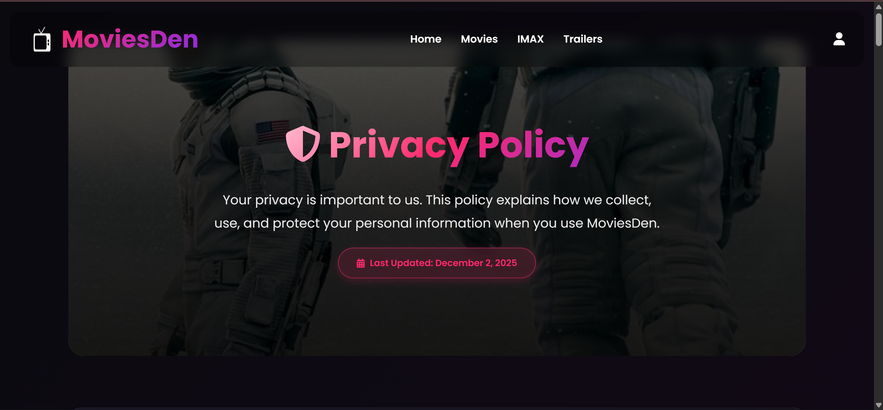

**Footer:**

This is our website footer, which appears at the bottom of every page.  
It contains important information like copyright, contact details, and quick links.

